**EXPERIMENT NO- 06**

**AIM:** Configuration of VLAN connection

**OBJECTIVE**: To demonstrate the Configuration of Cisco Router 2811.

**ALGORITHM:**

1. Start
2. Setup the Topology and initialize devices
3. Configure Devices and router and verify connectivity
4. Display Device information
5. End

**DESCRIPTION AND EXECUTION**: Resources: 1 Switch, 4 PCs, 1 Router.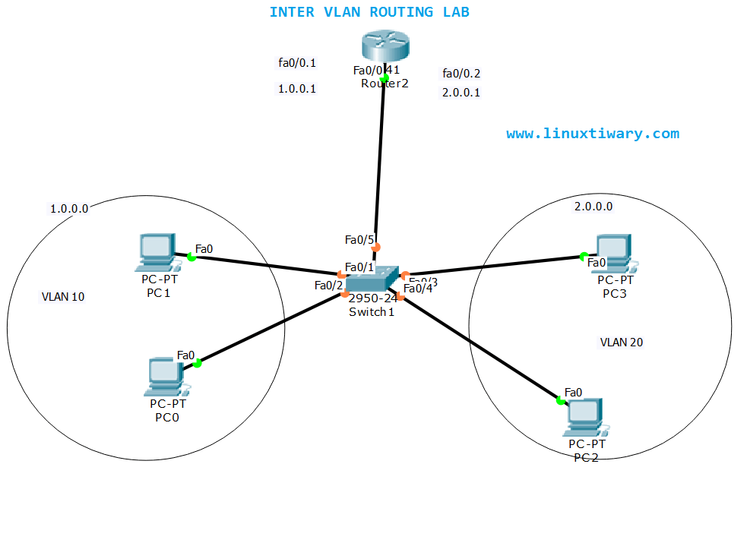

**Router no**.:2811

**Switch no**: 2950 -24

**Ip address of router**:192.168.10.1

**Subnet mask**: 255.255.255.0

The router must be enabled & label should be given .

**Pc on the left of the switch:**

Ip Address - 192.168.10.2

- 192.168.10.3

Subnet mask: 255.255.255.0

Default gateway: 192.168.10.1

**Pc on the right of the switch**:

Ip Address - 192.168.20.2

- 192.168.20.3

Subnet mask: 255.255.255.0

Default gateway: 192.168.20.1

**Switch**: goto

—-> config —> switching —-> VLAN database

VLAN number: 20

VLAN name: lab7

Under interface - FA 0/1,0/2 - – – - - -

For the PC’s on the left connected to

FA 0/2 and FA 0/3 – Remain

VLAN from 1 default & FA 0/4 & FA 0/5 — change to 20

**GO to the router**:

—> switching —-> VLAN database

# ADD VLAN number 20

VLAN name lab7

# go to CLI

**Steps :**

Type exit —-> router(VLAN) #exit

Router #config t

Router (config) #int f 0/0.1

Encapsulation dot 1q 20

Router (config- subif) #

Ip address 192.168.20.1 255.255.255.0

# change the connection of the switch to the router interface i.e FA 0/1 from access to trunk is the dropbox

# main step

Change 2 rightmost FA 0/4 & FA 0/5 connections of pc to VLAN 20 lab7 and the 2 leftmost FA 0/2 & FA 0/3 connections should remain default 1 in the interface of the switch.

ROUTER:

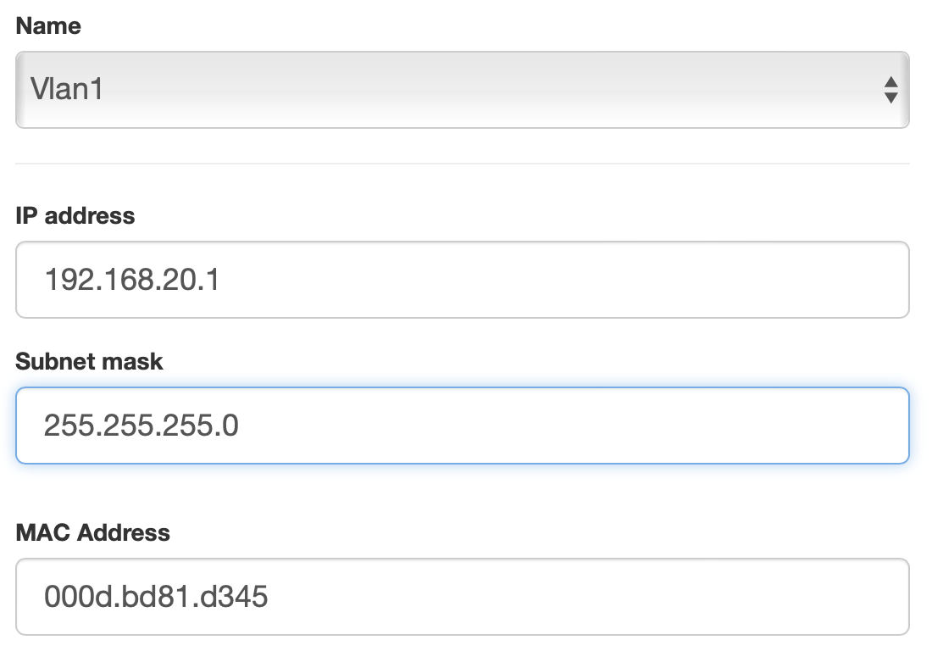

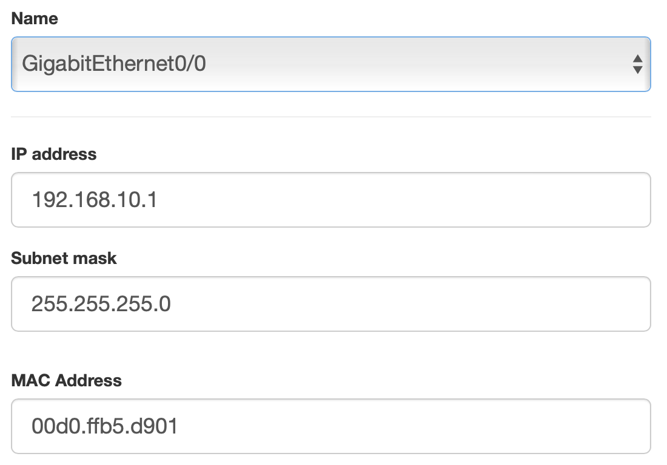

SWITCH:

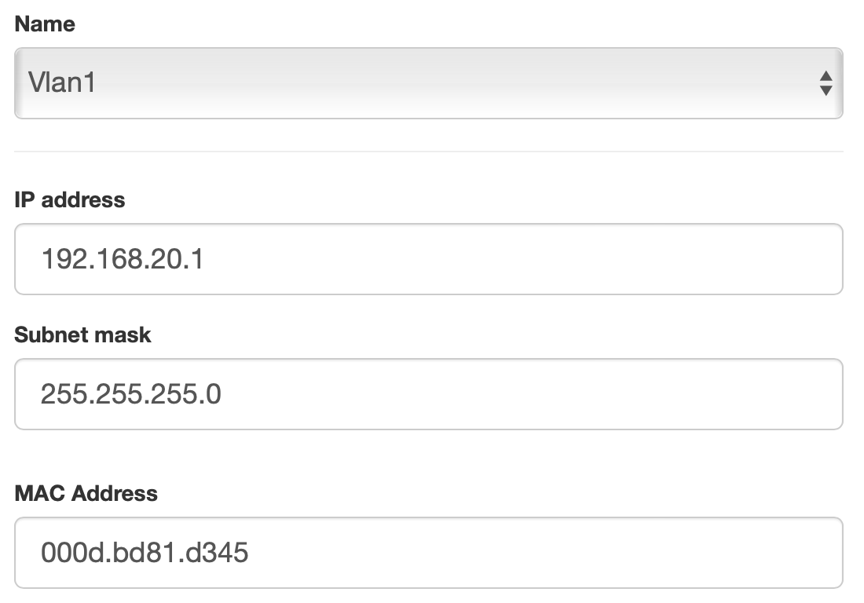

PC -0

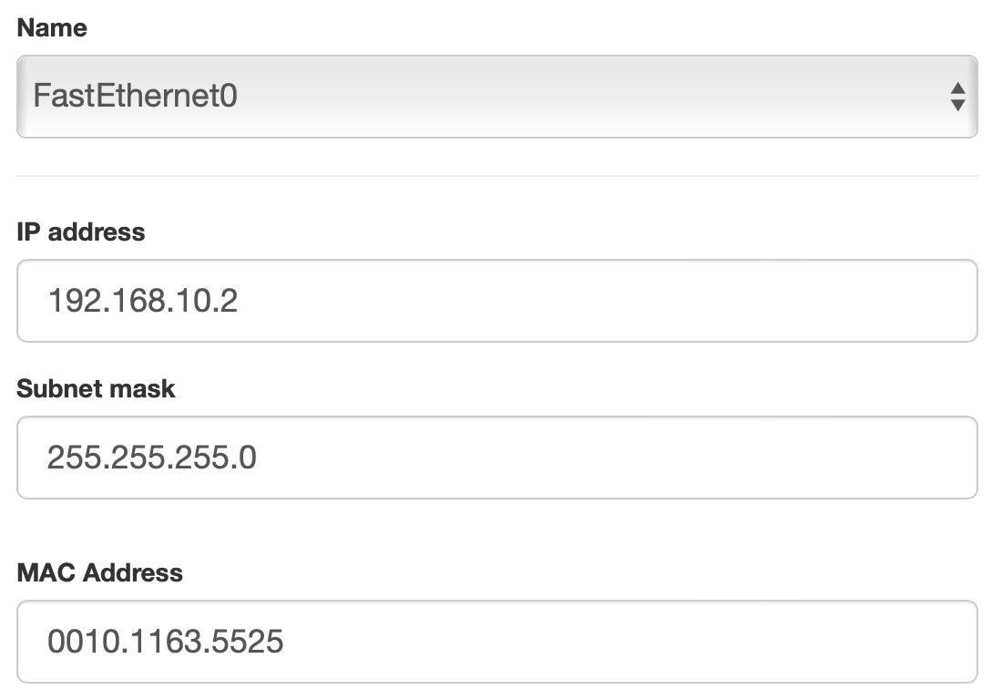

PC- 1:

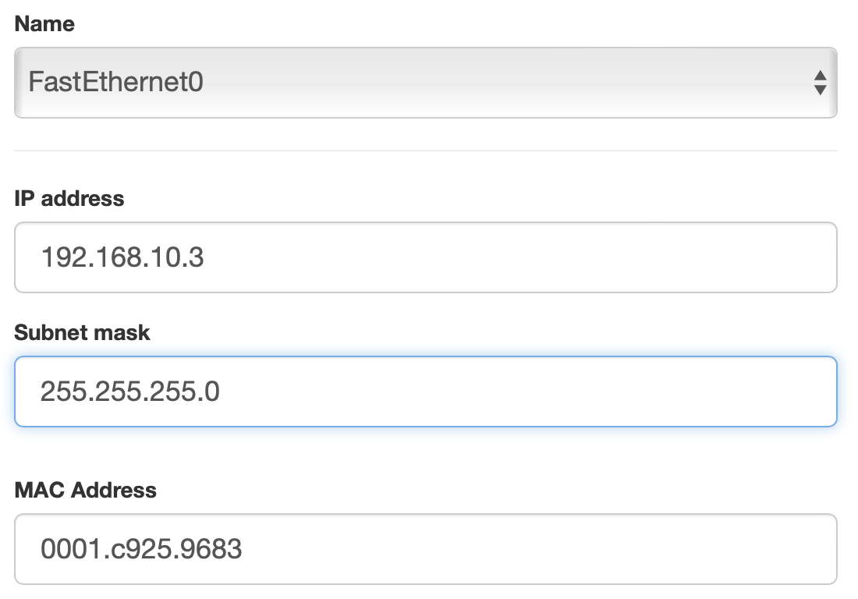

PC - 2:

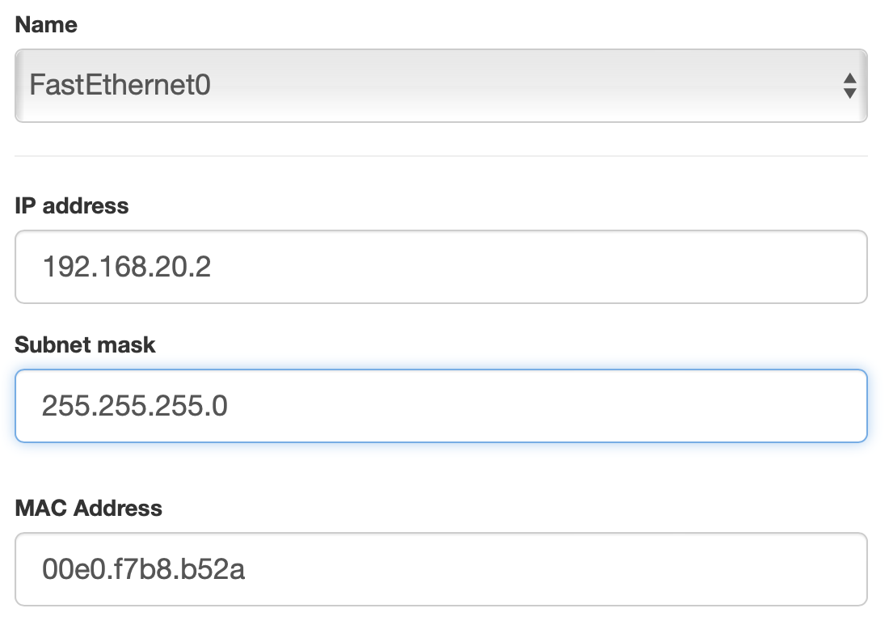

PC - 3:

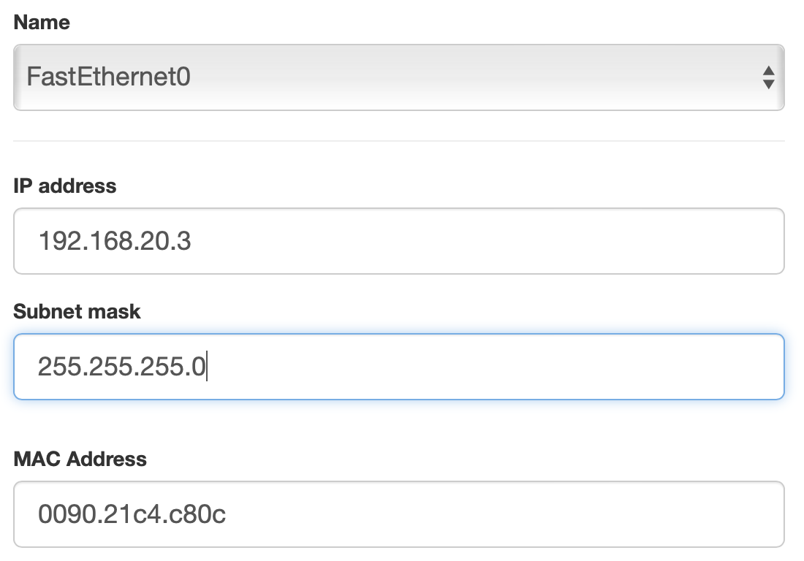

COMMAND LINE INTERFACE:

